Learn what to say at ruok.org.au A conversation could change a life

Your guide to supporting R U OK?Day
MORE TO SAY
THERE’S
AFTER

R U OK?Day 2020
The R U OK? mission is to inspire and empower everyone to meaningfully connect with and support those around them.
R U OK?Day is Thursday 10 September 2020. It’s our national day of action when we remind Australians that every day is the day to ask, “Are you OK?” if someone in your world is struggling with life’s ups and downs.

‘There’s more to say after R U OK?’
2020 has been a challenging year for many and circumstances have made it even more important for us all to stay connected and, for those who are able, be willing to support those around us.
In the lead-up to R U OK?Day we’ll help Australians know what to say when someone says they’re not OK and guide them through how they can continue a conversation that could change a life.
This guide has tips, ideas and resources to help you share our message and encourage everyone in your community to learn what to say after R U OK?

Contents:
There’s more to say after R U OK? quick guide p 4 Activity ideas and resources p 10 Resources to download, print and share p 17 Promoting your efforts p 20
Messages you can share p 22
Creative content ideas p 24
Templates p 25
Useful contacts for someone who’s not OK p 31

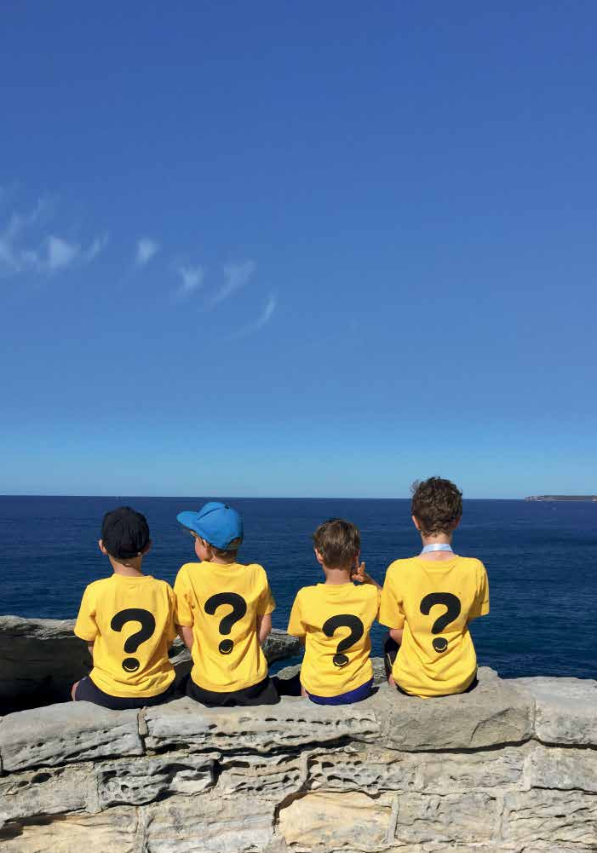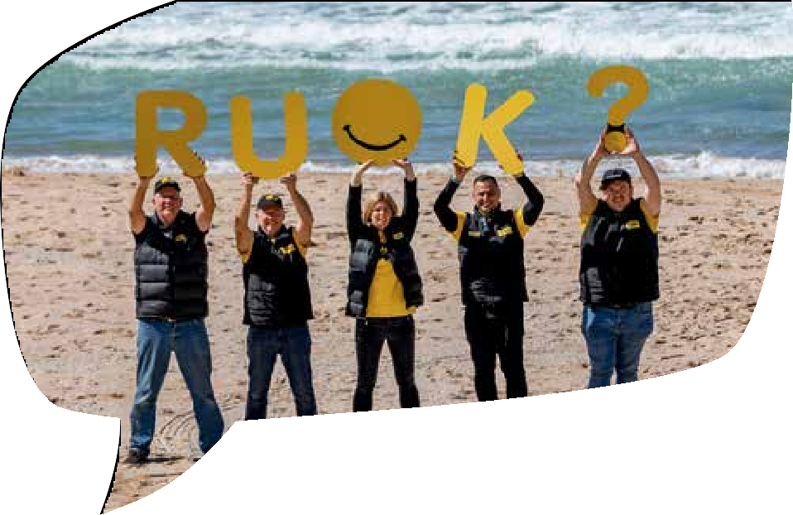

2 3
3

There’s more to say after R U OK?

Ask then listen, encourage action and check in

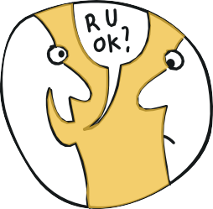
- Ask R U OK?
4
5

Or say something like:
“I’ve noticed a few changes in what you’ve been saying/doing. How are things for you at the moment?”
“I know there’s been some big life changes for you recently. How are you going with that?”
“You don’t seem yourself lately – want to talk about it?”
“Just checking in to see how you’re going?”
“With everything that’s going on, you’ve been on my mind lately, how are you?”
“You’ve got a lot going on right now. How are you doing?”

Listen

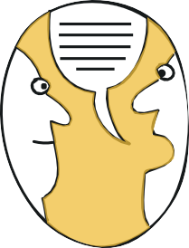
You could say:
“What’s been happening?”
“Have you been feeling this way for a while?” “I’m here to listen if you want to talk more.”
“I’m not going to pretend I know what it’s like for you, but I’m here to listen to why you feel the way you do.”
“It sounds like that would be really tough. How are you going with managing it?”
“Do you feel like chatting a bit longer? I’m ready to listen.”
“So, what was that like?”
“That’s tough. Keep talking, I’m listening.”
“What you’re going through isn’t easy, It’s good we can talk about it.
“Thank you for sharing this with me. That can’t have been easy for you.”
“Take your time, I’m here for you.”
“If there’s something you’re unsure about sharing with me right now, I just want you to know I’m here when you’re ready?”
5

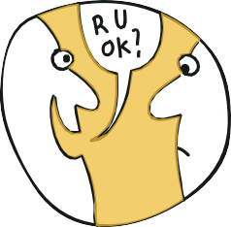
Encourage action

You could say:
“What do you think is a first step that would help you through this?”
“What can I do right now to support you?”
“Have you spoken to your doctor or another health professional about this? It might be a matter of finding the right fit with someone.”
“Have you had much support around you?”
“What’s something you enjoy doing? Making time for that can really help.”
“Do you think it would help for you to talk to someone else about some of these things, maybe a health professional?”
“Is there anything you’ve tried in the past when you’ve felt like this, that’s made you feel better?”
“I know when I went through something similar, talking to a professional really helped me out. Would you like me to help you book an appointment?”

Check in

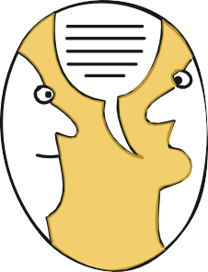
You could say:
“I would like to keep checking in with you, is that OK?”
“Hey, how have you been since we last chatted?”
“Just wanted to check in and see how you’re doing?”
“Have things improved or changed since we last spoke?”
“What’s been working for you since we last chatted?”
“Is the support we discussed working for you?” “Do you need more support?”

Learn what to say after R U OK? at ruok.org.au

6 7
7

What if they’re not ready to talk?
If they’re not ready to talk you could say:
“It’s just that you don’t seem like yourself lately.” “I’m always here if you want to chat.”
“These conversations aren’t always easy but know I’m here for you anytime you want to talk.”
“Is there someone else you trust that you feel you can talk to? Would you like me to set this up/come with you?”

What if they say I’m fine?
If they say they’re fine but your gut is telling you they’re not, ask again. You could say:
“It’s just that you don’t seem yourself lately”
“I know sometimes when I say, ‘I’m fine’ I’m far from it. Are you really OK?”
“If you’re not ready to talk that’s OK. I’m always here for you.”

Learn what to say after R U OK? and find more conversation tips on our website and in ‘Your guide to what to say after R U OK?’
which you can download at www.ruok.org.au/how-to-ask

8 9

Activity ideas & resources
This year’s message for R U OK?Day is ‘There’s more to say after
R U OK?’. We want you to be creative and think of ways you can bring people together to learn what to say after R U OK? to support anyone who might be struggling with life.

4 tips for a meaningful activity:
- Champions: Recruit and involve people who believe in the power of a conversation to help you organise and deliver your R U OK?Day activities. They can champion the R U OK? message in your school, workplace or community on R U OK?Day and all year round.
- Educate and inspire: Share stories about how conversations can change lives and provide tips, resources and information about what to say after R U OK?
- Get organised: Whether it’s a morning tea, a sausage sizzle or an online event, a well organised activity can have a positive impact on the lives of those taking part.
- Stay connected: Plan activities that provide opportunities (and encouragement) for people to talk to one another. They might not talk about life’s big issues, but they will get to know each other a little better and that can break down barriers for meaningful conversations in the future.
Activity ideas:

When planning your event or activities please refer to official government information and guidelines to ensure you have COVID safe procedures in place.
If you’re planning an event with people attending in person:
Work with other people who are passionate about R U OK? to design an activity for the day. This might include a walk and talk, a pledge wall where people promise to have meaningful conversations and learn what to say after R U OK? or you could organise an opportunity for people to meet a friend for a cuppa and a conversation.
Host an event. You could organise a breakfast, morning tea, BBQ, lunch and learn, team meeting or assembly.
Host an information session on what to say after R U OK? and think about including a video/webinar presentation for those who can’t attend.
Create a physical ‘Conversation Corner’ – designate a space in your school, workplace or community where people can come together, connect and have a meaningful conversation. Download our ‘Guide to Creating a Conversation Corner’ at www.ruok.org.au/create-a-conversation-corner
Host an R U OK? Round in your sporting community. Download our guide to hosting
an R U OK? Round at www.ruok.org.au/sport

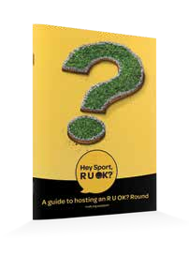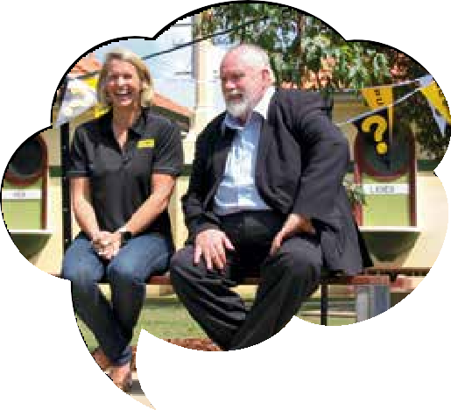

10 11

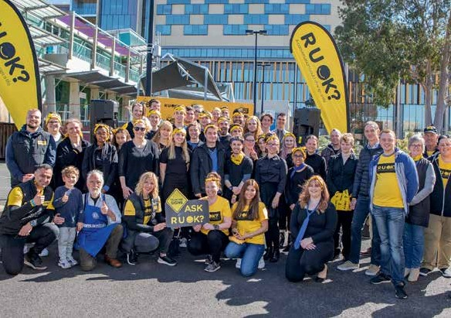
Register your event
Hosting an event is a great way to bring people together and share the R U OK? message. Register your R U OK? event with us and we’ll help

Register your event at www.ruok.org.au/events

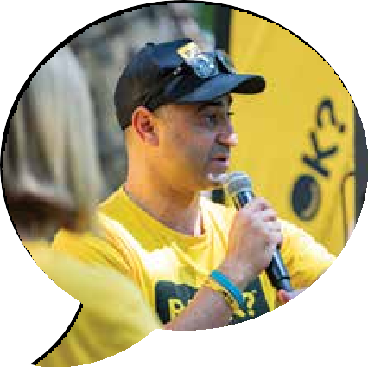Activity ideas while physically distancing
Host an R U OK? Community Ambassador
An R U OK? Community Ambassador (subject to availability) can present to your school, workplace or community
in person or virtually. Our Ambassadors are trained and able to share their personal story, the R U OK? message and can answer questions from the audience.
If you’d like to request a Community Ambassador for your event, please email events@ruok.org.au
Host a digital event. Make use of technology that can bring people together online. People can bring their own treats and conversation starters to the virtual gathering.
Create an online ‘Conversation Corner’. Create a team or group communication channel where you can regularly check in and ask one another, “Are you OK?”. Share conversation tips and help-seeking information so people can confidently navigate a conversation where someone says, “No, I’m not OK.”
Print and drop resources in places where people will see them (e.g. desks and communal areas). This could include conversation
cards, conversation starters or information about planned activities. Share information via email, social and other online channels.
Create and share content that explains what to say after R U OK? See the content ideas section of this guide for more tips.
Host a webinar or online discussion exploring what to say after R U OK?
Place conversation starters and phrases that show what people can say after R U OK?

12 13

Fundraising for R U OK?
Fundraising for R U OK? contributes to our efforts for friends, family, colleagues and neighbours to feel more connected and protected from suicide. Your support means that we can continue to provide essential, free resources to schools, workplaces, communities and families across Australia.
Download our fundraising guide for information and inspiration: ruok.org.au/fundraising
Safety first

Add a splash of yellow
R U OK? has a wide range of merchandise to help you add a splash
of yellow and encourage more conversations in your school, workplace or community.
Visit our store at store.ruok.org.au
Proceeds from the sale of merchandise support our work to start more life-changing conversations.

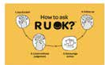
R U OK? is not a counselling service or service provider. Rather we work to provide all Australians with the resources and confidence they need to navigate a conversation with someone who might be struggling and guidance on how to connect them to appropriate support if they need it.
If you’re hosting an activity on R U OK?Day, we strongly encourage you to have appropriate support available and/or provide information about what support is available for people in your workplace, school or local community.
If you’re presenting or speaking about the R U OK? message, it’s important to acknowledge that some people in the audience might not be OK and encourage them to access appropriate support. You could say, “If today’s talk brings up tough emotions for you it’s OK to excuse yourself. If you need some extra support, I strongly encourage you to open up to someone you trust, connect with a trusted health professional or access a service like Lifeline which is available 24/7 on 13 11 14. You can find other services and support organisations on the R U OK? website at www.ruok.org.au/findhelp”

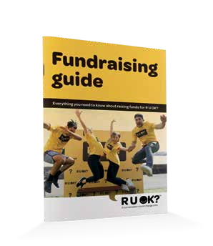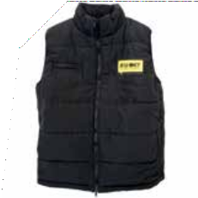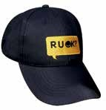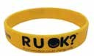

14 15

Social Media Moderation
When you share the R U OK? message on social media channels, some people might comment that they’re struggling or need some support. You can use the responses below to encourage people to access appropriate support.

If they’re not OK:
I really feel for you at this time and urge you to open up to someone you trust. Talking things through can help. If you need immediate support Lifeline are available 24/7 on 13 11 14 and other supports and services can be found at www.ruok.org.au/findhelp

If you’re concerned for their safety:

I’m concerned for your safety. If you feel your life is in danger, call 000 or Lifeline on 13 11 14.

You can find a directory of services and tools for someone who’s not OK at ruok.org.au/findhelp

Materials to download, print and share

Resources for ‘There’s more to say after R U OK?’
RU OK? has developed the following resources to help you encourage everyone in your school, workplace and community to learn what to say after R U OK?
Your guide to what to say after R U OK?
Presentation Pack
Activity sheet for young people Videos
Posters
Social media tiles TV/Display monitor artwork Screensavers
Email signatures

Learn what to say at ruok.org.au A conversation could change a life

You can download these resources at ruok.org.au/join-r-u-ok-day

16 17

Resources for every day of the year
Translated resources
R U OK? has a number of resources available in the following languages:
Arabic
Cantonese (Traditional Chinese)
Greek
Hindi Italian
Mandarin (simplified Chinese)
Punjabi Spanish
Vietnamese
You can access these resources at ruok.org.au/other-languages
R U OK? has developed resources tailored for:

Workplaces Schools
Community groups and organisations
Universities and TAFEs
Rural and remote communities
Aboriginal and Torres Strait Islander communities
Emergency services workers and volunteers
Sports clubs and associations

You can view and download these resources at
ruok.org.au/every-day-resources

ARE THEY TRIPLE OK?

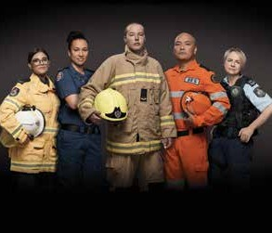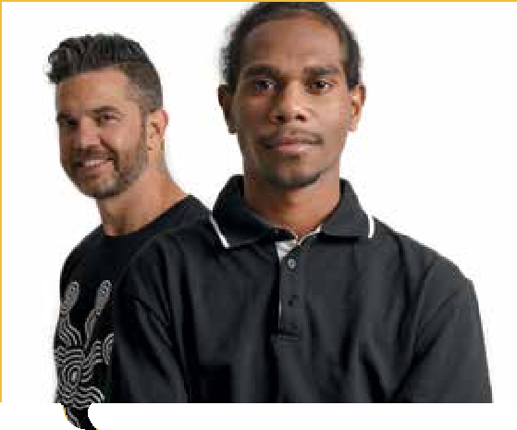A Researching the best artisan blends B Investigating latte art
18
19
How you can help someone who’s doing it tough because of a natural disaster or emergency
MANUAL
MATESHIP
THE
C Finding out how your friend is doing

Exams can be a testing time
Ask

Let’s share, we’re stronger together
“When we talk we are sharing. For thousands of years we’ve shared experiences, shared love. The only way we get out of those tough times is by sharing and talking.”
#RUOKstrongertogether ruok.org.au/strongertogether

We’re always there to help.
Let’s make sure we help each other and ask R U OK?
ruok..org..au/triiplle-ok

Promote your efforts
The continued success of R U OK? relies on the efforts of those in the community who independently organise, promote and manage events and activities in support of R U OK?
We strongly encourage you to use the resources available at
ruok.org.au to promote your events and activities.
Use of the R U OK? name and logo is restricted so if you plan to produce your own resources please ensure you use the appropriate logo and use it according to the following conditions.

Logo type and use
Trademarks
R U OK? reserves the right to determine if an organisation or individual is engaging in unfair use of the R U OK? trademark for commercial or personal gain, and to request removal or amendment at our discretion. For example, an organisation who exhibits trademark usage that overstates the level of support provided to R U OK?
R U OK? has identified industry sectors and activities that do not align with our trademark. These include:
Tobacco manufacture and sale. Armaments manufacture or export.
Gambling establishments such as casinos and bookmakers where the primary business is wagering. (Licensed clubs and venues
may be considered.)
Artwork, products and activities involving the perceived objectification and manipulation of children, women or men (including magazines, books, calendars,

‘Proudly supporting R U OK?’

Commercial activities
‘We make time to ask R U OK?’

Community activities
films and websites). Pornography.
Practices that abuse and/

These logos can be downloaded at www.ruok.org.au/logos
There must be no changes to colour or design when reproducing the R U OK? logos
The relationship between the activity and R U OK? must be clearly stated. For example, ‘In support of R U OK?’ or ‘All money raised will be donated to R U OK?’
or endanger Aboriginal and Torres Strait Islander people.

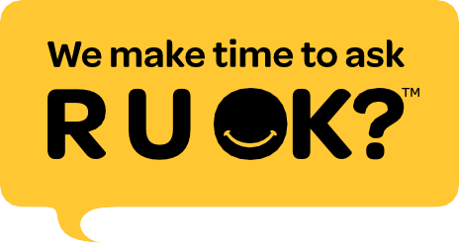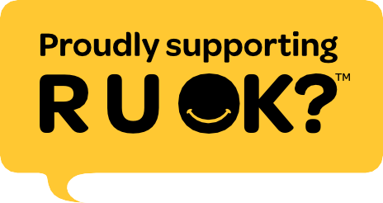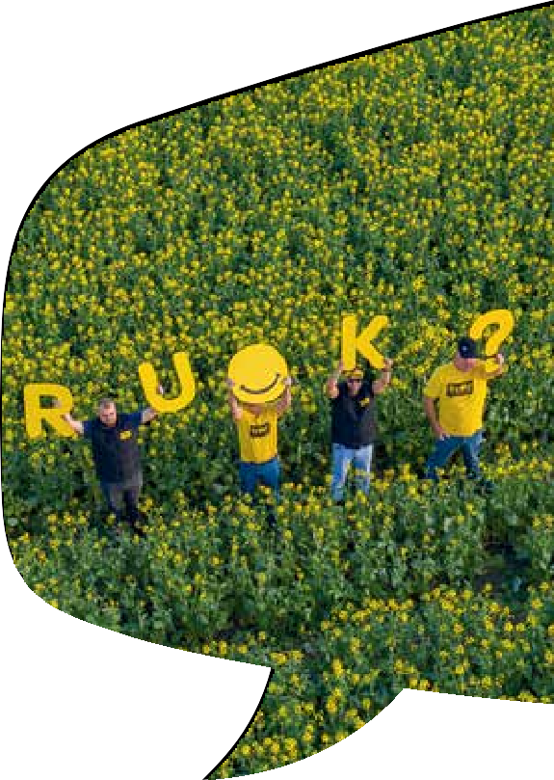

20 21

Messages you can share

General messages
There’s more to say after “Are you OK?”
Ask, then listen, encourage action and check-in. Learn what to say at www.ruok.org.au

Messages for adults
A conversation could change a life.
If you feel like something’s not quite the same with someone you know – there’s something going on in their life or you notice a change in what they’re saying or doing - trust that gut instinct and take the time to ask them “Are you OK?”
If someone says they’re not OK, make time to listen, encourage action and check in.
There’s more to say after R U OK? Learn what to say at www.ruok.org.au

Messages for young people
You’re never too young to look out for one another and ask R U OK?
When you ask the question, you’re not expected to fix their problems or know the best way to help and support. But you can listen to what they’re saying and tell a teacher, school counsellor or trusted adult if you’re worried about someone.
R U OK? has tips and resources that guide you on what to say when they’re not OK.
Learn what to say after R U OK? at www.ruok.org.au

Messages when encouraging people to support your efforts
We have a responsibility to help people in our community feel safe and supported.
Help me encourage everyone to look out for each other, especially when we think someone might be struggling.
Let’s increase people’s confidence and capacity to talk to each other about life’s ups and downs.
R U OK?Day is Thursday 10 September.
Let’s support R U OK?Day and reinforce the message that there’s more to say after R U OK?
We can host activities and share resources that help people learn how to keep the conversation going when someone says they’re not OK.
The resources will guide them through how to ask, then listen, encourage action and check in.
R U OK?Day is an initiative of R U OK? a national charity dedicated to inspiring all of us to have regular, meaningful conversations to support anyone struggling with life’s ups and downs.
Learn more about R U OK?Day at www.ruok.org.au

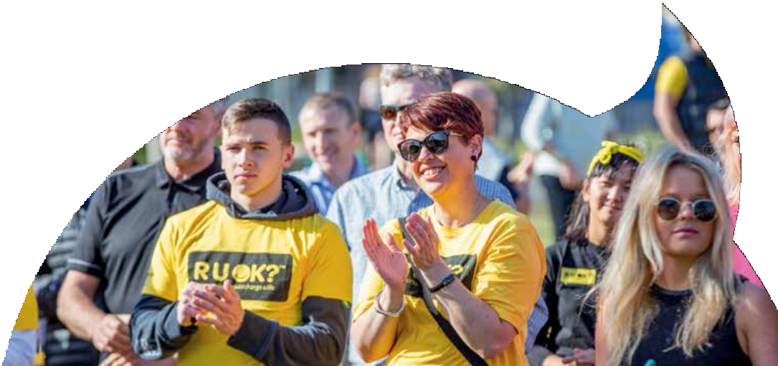

22 23

Templates
These templates have been created as a guide that you can adapt to suit your individual needs.

Creative content ideas
Social media
#RUOKDay (Thurs 10 September) is a reminder that a conversation could change a life. This year I’m learning what to say after R U OK? so I can keep the conversation going when someone says “No, I’m not OK”. You can too! Visit www.ruok.org.au #theresmoretosay
#RUOK is an important question but there’s more to say after
R U OK? Ask, then listen, encourage action and check in because a conversation could change a life. Learn what to say after R U OK? at www.ruok.org.au #theresmoretosay
When you notice the signs someone is struggling, take the time to ask R U OK? If they say they’re not OK make time to listen, encourage action and check in. Remember, there’s more to say after R U OK? Learn what to say next at www.ruok.org.au #theresmoretosay
Ask someone who’s passionate about the R U OK? message to write a blog, newsletter article or to share their story online, in print or in person in the lead-up to R U OK?Day.

They could:
Talk about what to say after R U OK?
Share a story that shows how asking R U OK? can make a difference Reflect on the role we can all play to help someone navigate
life’s ups and downs
Discuss why they think it’s important that we know how to keep the conversation going when someone says, “No, I’m not OK.”
Share what they say after R U OK? and their tips for keeping the conversation going
Discuss how they think R U OK? is making a difference
Thank the people in their life who knew there was more to say after R U OK? and supported them through a tough time.
You can also share content from the R U OK? website and social media channels.

24 25

Email Newsletter or blog

There’s more to say after R U OK?
There’s more to say after R U OK?
Thursday 10 September is R U OK?Day – and a reminder that on every day of the year we should support people who may be struggling.
But there’s more to say after R U OK?
If someone says they’re not OK make time to listen, encourage action and check in.
To help people keep the conversation going when someone says they’re not OK we’re encouraging everyone to learn what to say after R U OK?
To spread this message, we’ll be sharing information and resources that guide you through what to say after R U OK? We’ll also be: [If you are running an event or activity, you can include the information about it here].
If you need immediate crisis or emotional support you can contact Lifeline on 13 11 14 or [If have local support service include the details here].
R U OK? is a national charity dedicated to inspiring all of us to have regular, meaningful conversations to support anyone struggling with life’s ups and downs.
You can learn what to say after R U OK? at
www.ruok.org.au

Are you OK? is a question we need to ask genuinely and sincerely any time we notice the signs someone may be struggling. But there’s more to say after R U OK?
When someone says they’re not OK, make time to listen, encourage action and check in.
National suicide prevention charity R U OK? has developed resources that provide simple tips to help people keep the conversation going and know what to say after R U OK?
Download them at www.ruok.org.au
We want to encourage everyone to keep the conversation going and will be supporting R U OK?Day on Thursday 10 September.
On this day we’re calling on everyone to learn what to say after R U OK? [you could include details here of what activities you have planned for R U OK?Day].
We want everyone in our community to feel they can talk about life’s ups and downs and access support if they need it.
[If you have a local support service include the details here].
R U OK? encourages all of us to have regular, meaningful conversations to support anyone struggling with life’s ups and downs.
You can learn what to say after R U OK? at www.ruok.org.au

26 27

Media release
Let local media know about your R U OK? event or activities and help people know what to say after R U OK?. They can help you spread the word by
running a story about your awareness raising efforts and local support services. Make sure you reach out to
them at least two weeks before your event with details of what you’re doing and why.

Things to remember:
If someone in the media asks you for information about R U OK? or suicide prevention, please ask them to contact media@ruok.org.au
We encourage you to speak about your event and why you’ve decided to organise it, but please ensure it is clear that you are not an official spokesperson or representative of R U OK?
Good luck!

Media Release Example
Title: (LOCATION) shows there’s more to say after R U OK? at (EVENT/ACTIVITY NAME)
(ORGANISATION) is hosting an event on (DATE OF EVENT) to encourage friends, loved ones and colleagues to start a meaningful conversation with anyone they are worried about and to support R U OK?
(LOCATION) (TODAY’S DATE): To remind Australians that there’s more to say after R U OK? (ORGANISATION) is hosting an (awareness or fundraising) event (or activity) to show (LOCATION’S) (AUDIENCE e.g. youth) how to keep the conversation going when someone says they’re not OK. (TITLE OF
SPOKESPERSON first and EVENT SPOKESPERSON’S NAME) said, “Our friends, family members and workmates face life’s up’s and downs every day of the year.” “That’s why we’re hosting (EVENT NAME) to do what we can to get our community asking, ‘Are you OK?’ and knowing what to say,” (spokesperson) said.

28 29

Useful contacts for someone who is not OK
Encourage them to talk to a trusted health professional or call on these Australian crisis lines and professionals:

Lifeline (24/7)
13 11 14
lifeline.org.au

Suicide Call Back Service (24/7)
1300 659 467
suicidecallbackservice.org.au

Beyond Blue (24/7)
1300 224 636
beyondblue.org.au

Kids Helpline (24/7)
1800 55 1800
kidshelpline.com.au

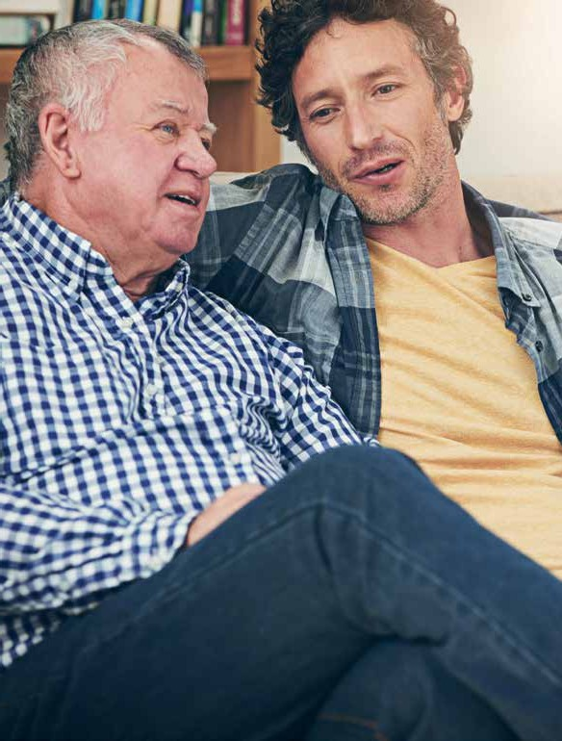
When sharing the R U OK? message we would encourage you to highlight the support tools that you currently offer or are available in your local area and these national helplines. Find more
services and tools at www.ruok.org.au/findhelp

For more information and resources:

ruok.org.au
/ruokday @ruokday @ruokday

30 31

ruok.org.au

